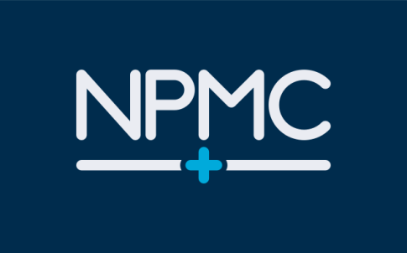
@ Willen

Guidance to keep you safe when attending your appointment
Coronavirus (COVID-19) has had a major impact on the NHS, including Newport Pagnell Medical Centre. As a result, you may have waited longer than normal for your appointment and we would like to apologise for this. We want to assure you that we will have a range of measures in place to help protect you from coronavirus if you are offered a face to face appointment.

Please DO NOT attend an appointment if you or any member of your household are suffering from any of the symptoms associated with COVID-19 or are self-isolating. If this applies to you, please contact us so that you can reschedule your appointment for a different time.

If you are identified as clinically extremely vulnerable and have been shielding, please contact us for further advice before attending a face to face appointment.

Travelling to and from your appointment
When travelling to and from your appointment, please follow guidelines which include keeping a safe distance from others and travelling by car, bike or walking if possible. Where possible wash your hands regularly and use hand sanitiser. Go to www.gov.uk and search for ‘staying safe outside your home’.

Wearing a face covering
In line with government advice, please wear a face covering to your appointment. This can be a mask you have bought or made, a face covering worn for religious or cultural reasons (as long as they cover the mouth and nose) or a surgical mask you have been given because you are shielding. For guidance on how to wear and make a face mask, visit www.gov.uk and search for ‘face covering’.

When attending your appointment
We have a range of measures to minimise the risk of COVID-19:
- social distancing measures will be in place
- there will be additional infection control procedures and clinical staff will be wearing personal protective equipment such as face masks
- your appointment may be at a clinic that is not your usual venue
- the appointment may take longer than usual.
Due to the COVID-19 response, our service will have a reduced number of appointments available. If you choose not to attend your appointment, please contact us. It is helpful for us to know why so we can help with any concerns you might have. If you still do not wish to attend, we can offer it to someone else.
Newport Pagnell Medical Centre
Queens Avenue
Newport Pagnell
MK16 8QT
Tel: 01908 611767
www.npmc.nhs.uk
mkccg.npmcmail@nhs.net

